W

e all have a soft spot for libraries. Maybe from being taken to the small local library by a primary school teacher to obtain our very own tickets to use whenever we wanted or maybe from visions of the towers of learning conjured up by the lost library of Alexandria, where all the learning of the world is held in one place to become engrossed in. Maybe we all, deep down, want to emulate those scholars. Of course, the state should pay for this—it is their duty to keep funding libraries so knowledge is freely available to all. Or should they?

**According to the government’s latest statistics, the number of adults using public libraries at least once a year has fallen from 48.2 per cent in 2005/06 to 39.4 per cent in 2009/10.** The number of people who visit a library on a weekly basis has dropped by 32 per cent in five years to just 5.4 per cent. Libraries are expected to face significant cuts as councils are told to reduce their budgets and in some rural areas, the suggestion is that, like post offices, libraries relocate to the local pub.

So, it is time to look afresh at library services?

When William Ewart, a liberal MP introduced the Public Libraries Bill in 1849, he met with considerable hostility from the Conservatives in the House of Commons. It was argued that the rate paying middle and upper classes would be paying for a service that would be mainly used by the working classes. One argued that the ‘people have too much knowledge already: it was much easier to manage them twenty years ago; the more education people get, the more difficult they are to manage.’ Reason enough, you might think, to keep funding libraries.

The Public Libraries Act became law in 1850. Borough Councils had to obtain the consent of two thirds of local ratepayers who voted in a referendum in order to charge one penny in the pound to fund the purchase of books. The penny rate (1855) still made it impossible for local authorities to provide libraries without the support of wealthy entrepreneurs. The greatest supporter of public libraries was Andrew Carnegie, who helped to finance over 380 libraries in Britain.

Libraries are not only a public service, but a fought-for part of our heritage. But is the provision of (Catherine Cookson, n.d.)to pensioners something the state should fund? If people are not using libraries, why should funding continue?

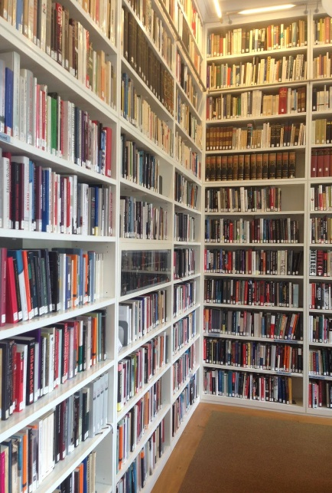

[This Photo](https://en.wikipedia.org/wiki/Wiener_Library_for_the_Study_of_the_Holocaust_and_Genocide) by Unknown Author is licensed under [CC BY-SA](https://creativecommons.org/licenses/by-sa/3.0/)

Enter into this discussion the new super-libraries that are cropping up all over the country. Whitechapel has the Ideas Store, Newcastle its Central Library, Brighton got a new one in 2005, and Birmingham’s is in the process of being built at a cost of £193 million. The Ideas Store was my local library, a lovely building with the most fantastic librarians I have met. Unfortunately, it has few books. There are banks of computers, bookable seminar rooms, and specific activities for ethnic minorities, but bound paper is conspicuous by its absence.

Brighton library was distinguished when a builder found a skip full of books on their way to be pulped while working on the building site, he donated them to a local Oxfam shop. Mike Whitby, Leader of Birmingham City Council, when unveiling the design by Dutch architects Mecanoo Architecten, said ‘this is further evidence of our intention to attract world-class architects to work with the city’. The council’s website then spends another nine paragraphs talking about the building and its open-air space, an elevated garden with spectacular views over the city. When asked about the provision of library services, he went on to say that the library will not be bound by convention, rather it will be a palazzo of human thought. This turns out to mean the library will be a tourist attraction which will hopefully attract 10,000 visitors a week, and local services will be provided by rooms of DJ decks that allow ‘youth’ to engage, because of course youth do not want to read books.

So, are these new libraries actually libraries? This is what Birmingham Salon’s next meeting on the 22nd of September hopes to pry out of Brian Gambles, head of Birmingham library services. The investment going into these ‘landmark’ buildings is substantial, but very little has been heard about what it will provide for the city. Rumors of dance spaces, exhibition venues, cafes, internet services, DJ sessions, and roof-top gardens are all well and good if that is what we want from a library. Unlike in 1850, there is no referendum to decide this.

One of the problems with libraries is how much more they are being expected to do. They must contribute toward the nation’s economic activity, the Olympics, engage the socially excluded, and so on. Librarians have been forced to go along with these expanding agendas in the hope that if they result in more people coming into the library, political eyes will be drawn away from cutting ‘core services’. But what are core services? There are 13 million less books available to borrow than 6 years ago. Councils do not want librarians in their new super-libraries—they would prefer volunteers. Librarians are portrayed as over-skilled and have a tendency to make value judgements about the books on their shelves. So, not only books, but professional expertise is gone. Both ‘core’ surely?

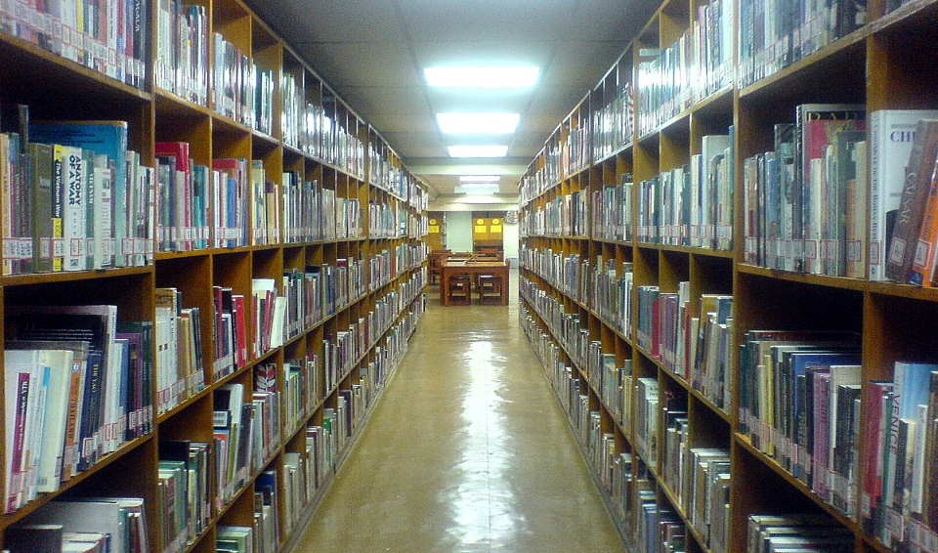

[This Photo](https://en.wikipedia.org/wiki/School_library) by Unknown Author is licensed under [CC BY-SA](https://creativecommons.org/licenses/by-sa/3.0/)

It seems also that the rules of Silence! is not popular. According to Rachel van Riel, author of ‘The Reader Friendly Library Service’, “young people have grown up in a world of noise. They experience silence as something oppressive. Silence is to do with being restricted, punished and is not a comfortable state of being”. Further, apparently one of the main reasons teenagers go to libraries is to find a quiet corner in which to snog, and why not asks Rachel. Providing an outlet for adolescent hormones might be a core service then?

Just down the road from the Ideas Store is the old Whitechapel library next to Aldgate East tube station, which closed to make way for the Ideas Store. It was an important local institution for the Jewish community in the area, nicknamed the University of the Ghetto, and many writers who grew up in the area were regular visitors, using the library as an escape, and its books as an education. In the East-End of London with mass immigration into Stepney, Whitechapel, and Bethnal Green in the late 19th century, immigrants flocked to the local library on Whitechapel road to continue studies they started in homelands until they were forced to leave.

# Bibliography

*Catherine Cookson*. (n.d.). Retrieved from wikipedia: https://en.wikipedia.org/wiki/Catherine_Cookson

Smith, J. (n.d.). *Sample Articles*. Retrieved from Academic Help: https://academichelp.net/samples/creative-writing-samples/article-samples/what-are-libraries-for.html